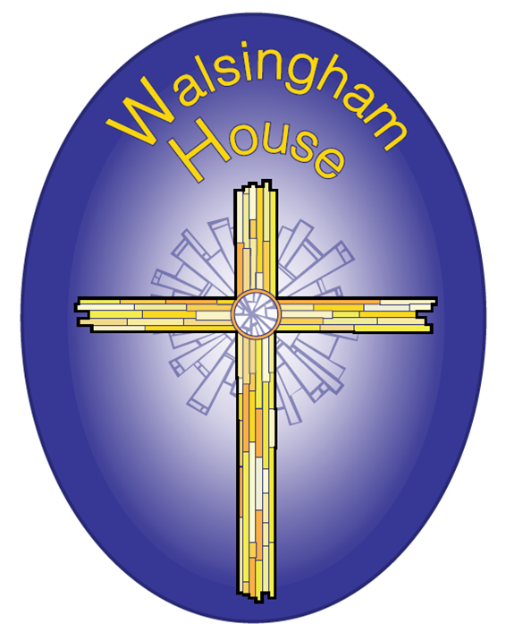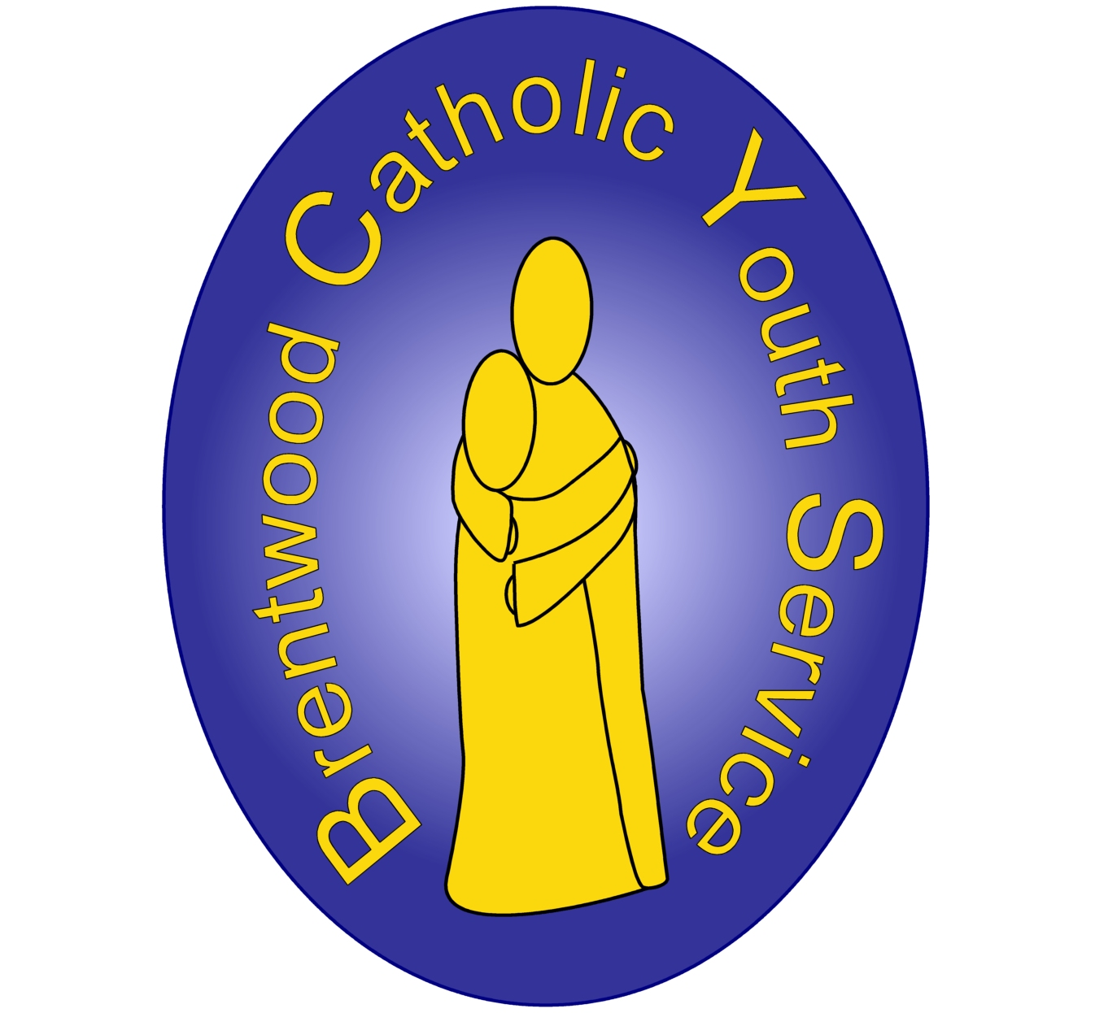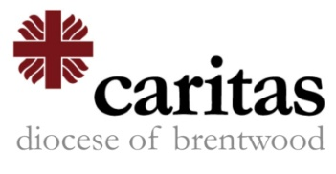

**Walsingham House at Abbotswick**

**Walsingham House at Abbotswick, Navestockside, Brentwood,**

**CM14 5SH**

**Telephone: 01277 373959**

**Email: info@bcys.net**

**Website:** [**www.bcys.net**](http://www.bcys.net)

We are a nonprofit making charity under the auspices of the Diocesan Trust (BRCDT), Registered Charity 234092

**Sample Year 6 Retreat   
“You are God’s Work of Art”**Ephesians 2:10

10.00 Arrivals, Introductions and Ice Breakers

Opening Prayer

Workshop 1

Break

Workshop 2

Workshop 3

Lunch

The memory wheel into Precious memories

2.15 Final Prayer - The Rainbow

2.30 Thank you and Goodbye

Workshops

How has God made me unique? - Inside Out

Real Life Superheroes – we’re all called to make a difference

God’s work of Art Meditation – reflect on the wonder of God’s creation