**Walsingham House at Abbotswick**

**Walsingham House at Abbotswick, Navestockside, Brentwood,**

**CM14 5SH**

**Telephone: 01277 373959**

**Email: info@bcys.net**

**Website:** [**www.bcys.net**](http://www.bcys.net)

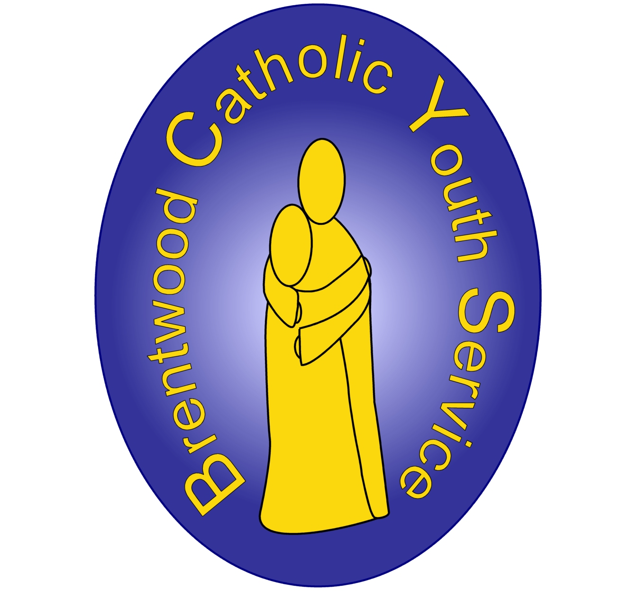

We are a nonprofit making charity under the auspices of the Diocesan Trust (BRCDT), Registered Charity 234092

**Sample Year 5 Retreat**

*The Parables*

10.00 Arrival and Icebreakers

10:20 Opening Prayer: The Parable of the Mustard Seed

10.30 Small group/small group game

10:50 Parable of the Builders Challenge

11:30 **Break**

11:50 Workshop 1

12:20 Workshop 2

12:50 **Lunch**

13.30 Game

13:45 Workshop 3

14.15 Workshop 4

14:45 Final Prayer

15.00 Goodbyes

Workshops

The Parable of the Lost Coin: Treasure Hunt – outside everywhere

The Parable of the Sower – meditation

The Parable of the Good Samaritan - Dramas – Main Lawn   
The Prodigal Son: Moana Film Clip and Story Board – Main Room

A time of interactive reflection on the Parable of the Mustard Seed, asking the young people about the importance of faith and how with it we can achieve the impossible.

**The Parable of the Builders: Challenge**Each small group will be given resources to build a model house. We will then see who have been the ‘wisest’ builders by testing if it can survive the wind and rain.Objective: A fun, competitive activity focusing on whether we place our foundations on solid ground or on sand.

**The Parable of the Lost Coin: Treasure Hunt**Looking at the Parable of the Lost Coin, we will have a fun treasure hunt around the grounds of Abbotswick. The group will have to solve riddles to find the ‘lost coin’ Objective: By looking at the story of the lost coin, we explore how God will always search for and find us, even when we feel lost.

**The Parable of the Good Samaritan: Social Justice**Following Catholic Social Teaching, we will focus on who are the people who fall by the side of the road, who are the people who ignore them, and how can we be more like the Good Samaritan. This session involves each small group working together to demonstrate how to be like the Good Samaritan today through a drama.

**The Parable of the Prodigal Son: Moana Film Clip and Story Board**Time to reflect on God’s love for us. We watch a clip about forgiveness from Moana and compare this to the story of the prodigal son. This is further understood throughout the group during a time of discussion. Each young person then has an opportunity to draw out a time they have felt like a prodigal child on a story board.

**Final Prayer**A reflection on the parables we heard today and what they have taught us about our relationship with God.